Name : Panthiv Patel

Roll no:72

Class: FYCS

Practical1:

Introduction and Contribution to Wikipedia

**a) Description about Wikipedia and its features:**

Wikipedia is a free, open content online encyclopedia created through the collaborative effort of a community of users known as Wikipedians. Anyone registered on the site can create an article for publication.Jimmy Wales and Larry Sanger co-founded Wikipedia as an offshoot of an earlier encyclopedia project, Nupedia, in January 2001. Originally, Wikipedia was created to provide content for Nupedia. However, as the wiki site became established it soon grew beyond the scope of the earlier project.

Its features:

* Creating a page
* Editing a page
* Link between pages
* It is globally available on all platforms
* it can provide a large amount of information
* Users can share their own thoughts and knowledge
* It is easy to use
* Available in multiple languages

**b) Creating Account on Wikipedia:**

Step 1: go to <https://en.wikipedia.org/wiki/Wikipedia> click on create account

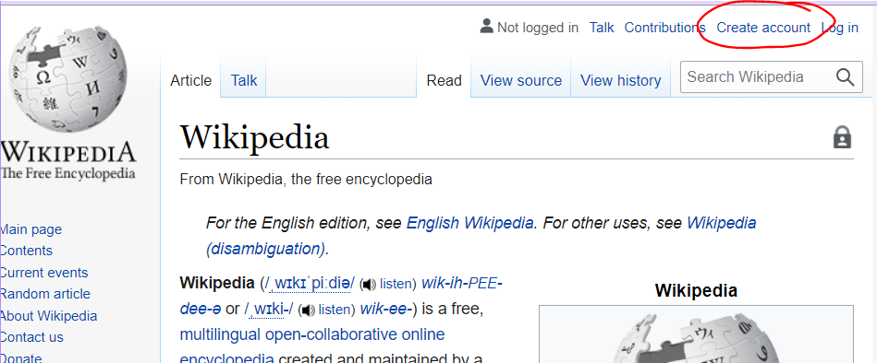

Step 2: fill in the details

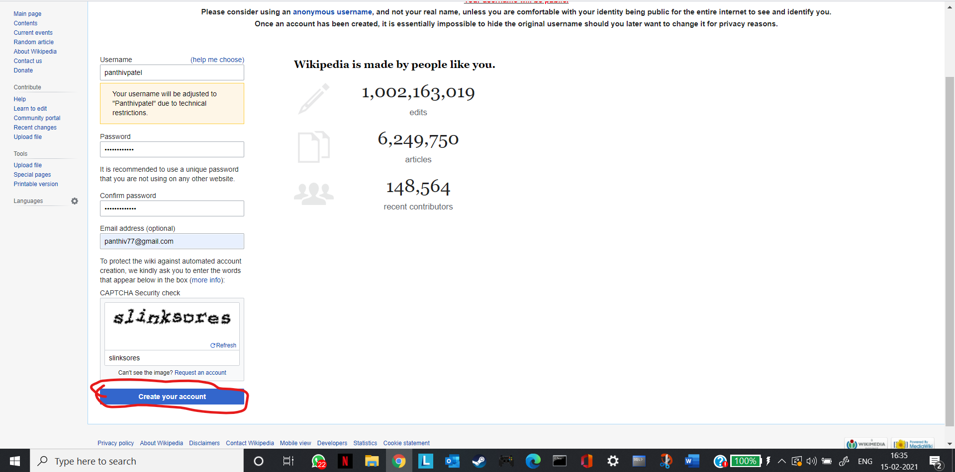

**c) Creating your page on Wikipedia**

Step 1: After creating the account for creating your own article by searching your name

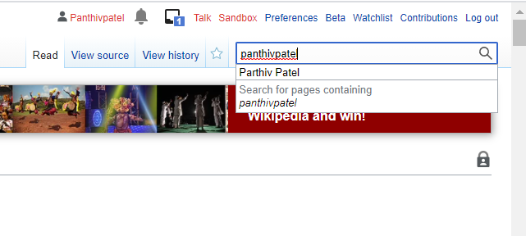

Step 2:You will be redirected to a page where it will be written  “as for it to be created” click on it

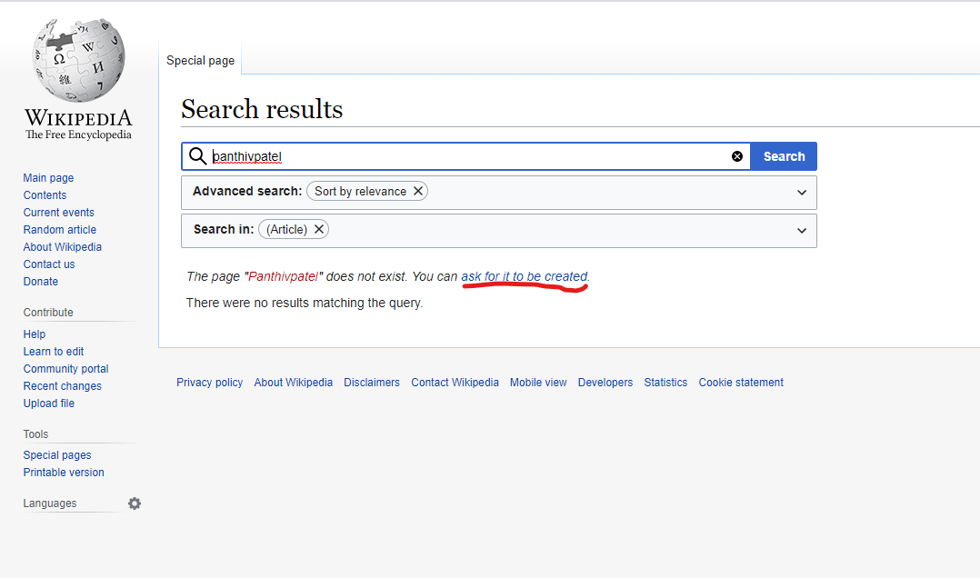

It will take to a page like this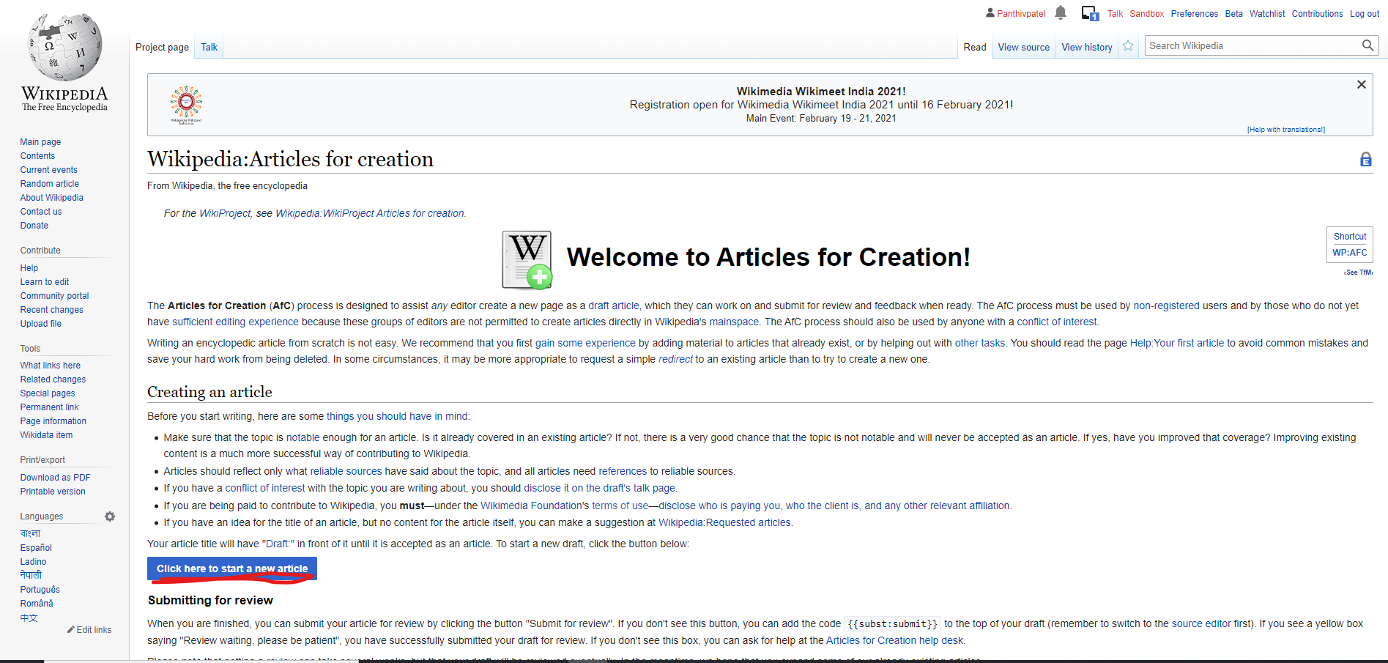

Step 3: You can click on next to get started or practice in the sandbox for rough article writing.

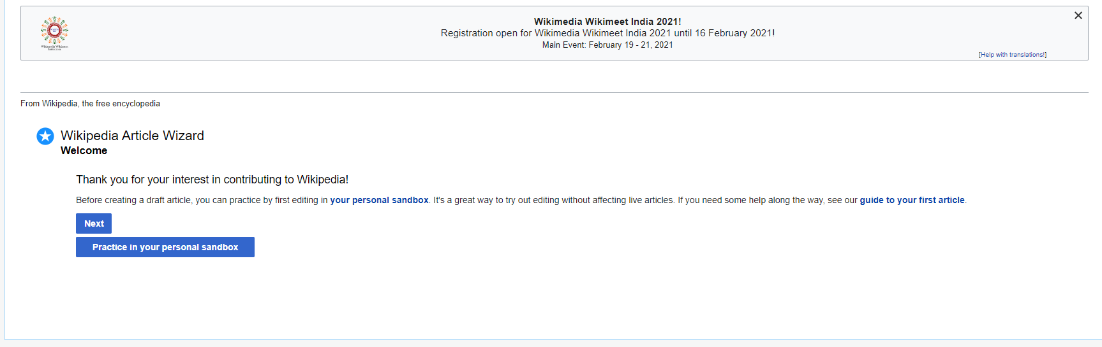

Click on next again and you will be redirected to a page like this:

Step 4: Click on i am writing for myself

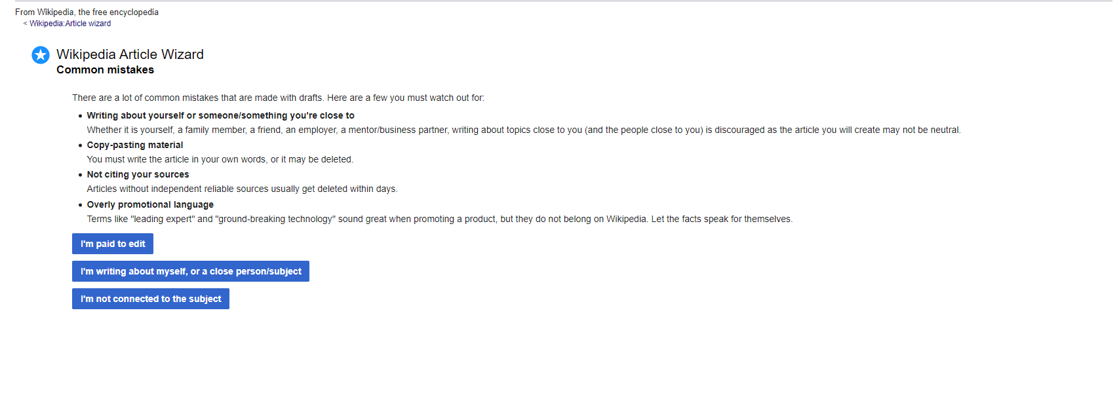

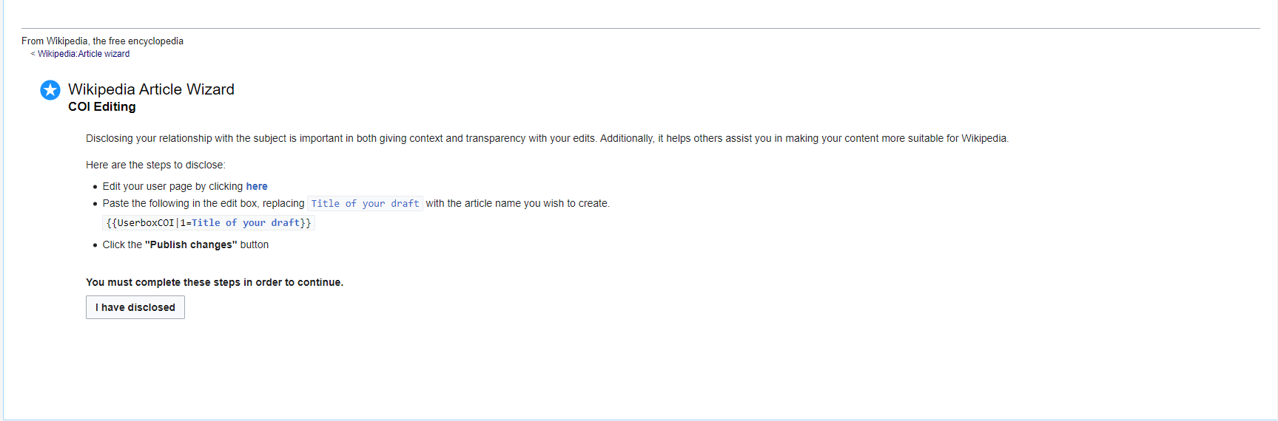

Click on i have disclosed. And then next

Step 5: Enter in your draft name and click on create new article draft

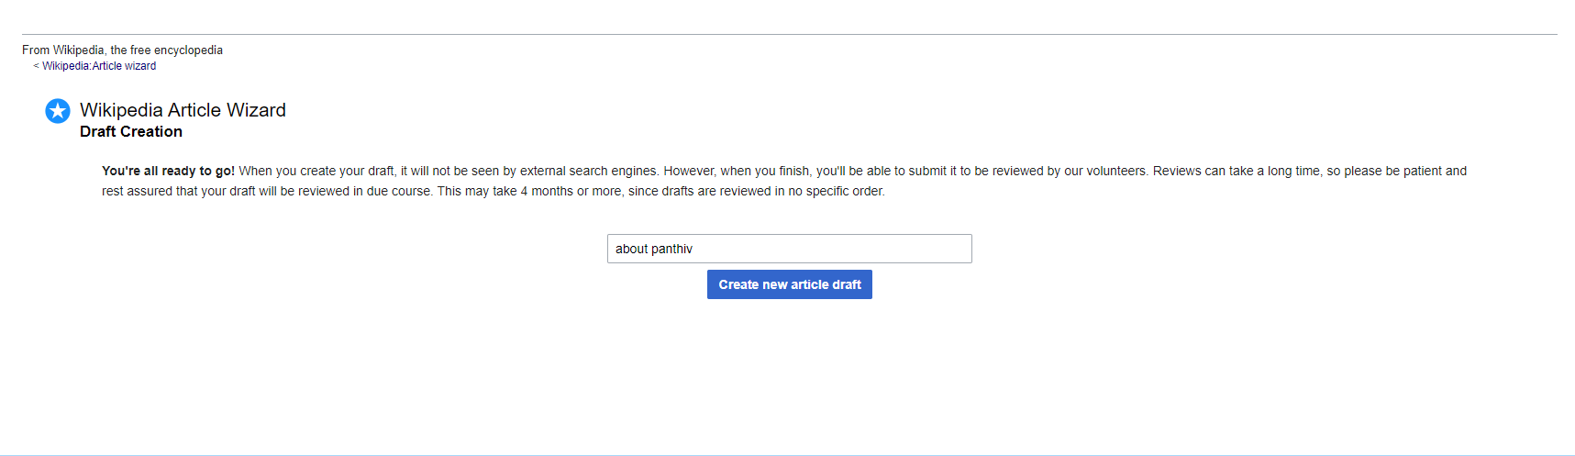

You will be redirected to the page where you can put your information or about the article you want to write about

For linking your page to another site or page you can click on the highlighted button

Step 6: Click on the publish page and then submit the draft to review.

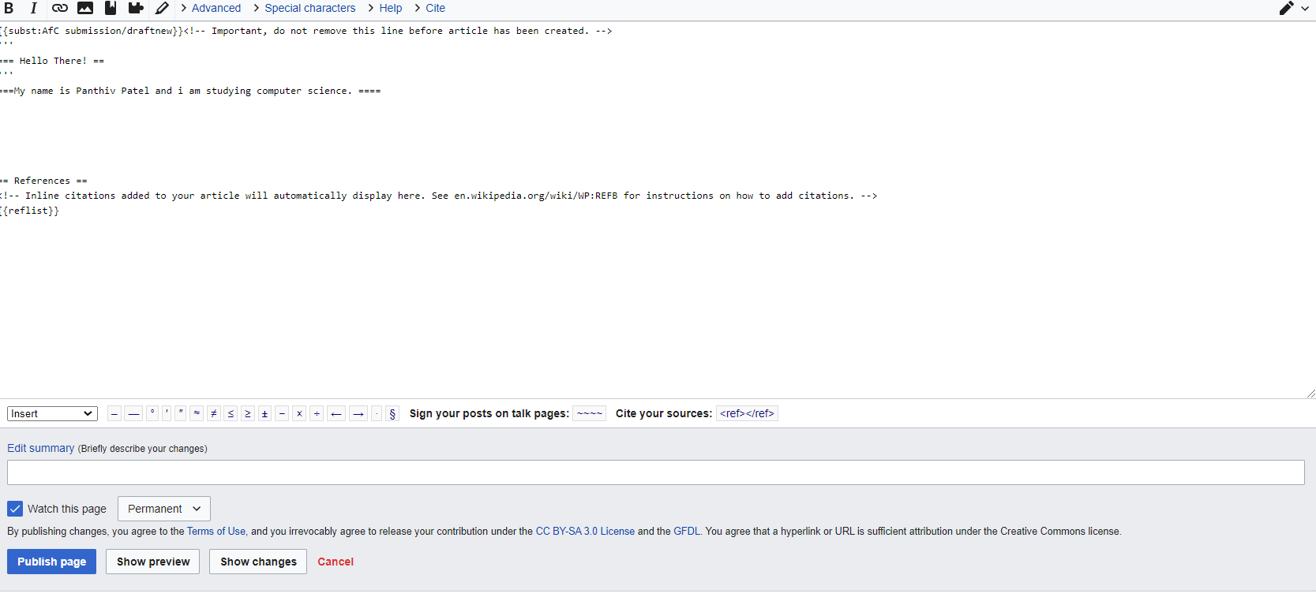

Step 7: Your article will be sent to review be patient with it

